Project Design Phase-II Technology Stack (Architecture & Stack)

|  |  |
| --- | --- |
| Date | 13 October 2022 |
| Team ID | PNT2022TMID07659 |
| Project Name | Fertilizer Recommendation for Disease Prediction |
| Maximum Marks | 4 Marks |

Technical Architecture:

The Deliverable shall include the architectural diagram as below and the information as per the table1 & table 2

Title: Fertilizer Recommendation System for Disease Prediction

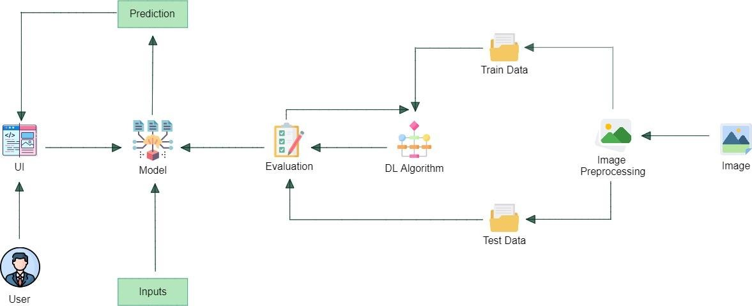

Table-1 : Components & Technologies:

|  |  |  |  |
| --- | --- | --- | --- |
| **S.No** | **Component** | **Description** | **Technology** |
| 1. | User Interface | User interacts with the application using a website | Python Flask |
| 2. | Image Preprocessing | Image of the diseased leaf is uploaded through the  website and the image is pre-processed using machine learning algorithms. | Python |
| 3. | Disease Prediction | Machine learning model to predict the diseases  from the images of the leaves uploaded through the website | Python |
| 4. | Fertilizer Recommendation | After predicting the disease suitable fertilizer for  that particular disease is suggested. | Python |
| 5. | Database | Images are stored in the database | Google drive |
| 6. | Cloud Database | The above described model is deployed in the IBM  cloud. | IBM DB2, IBM Cloudant etc. |
| 7. | Machine Learning Model | Machine learning models are used for image  pre-processing, disease prediction and fertilizer recommendation. | Image pre-processing model, Disease Prediction model. |

Table-2: Application Characteristics:

|  |  |  |  |
| --- | --- | --- | --- |
| **S.No** | **Characteristics** | **Description** | **Technology** |
| 1. | Open-Source Frameworks | Google Collaboratory, Jupyter Notebook, Google drive, Python Flask | Python, Data storage in Google drive |
| 2. | Scalable Architecture | The scalability architecture used is 2-tier architecture. The client is the user and the server  is the IBM cloud server where the model will be deployed. | Python Flask, IBM Cloud. |
| 3. | Availability | The website will be deployed in the IBM cloud and  will be available for all the users to use irrespective of the organisation or the institution they belong to. | IBM Cloud |
| 4. | Performance | As the models and the web applications are deployed in the IBM cloud remote server the website can handle maximum number of requests  and can be scaled at ease. | IBM Cloud |